Final Report

Satvik Kulshreshtha

Course: CSE 178 – Computer Network Security

Instructor: Professor Mukesh Singhal

TA: Mina Naghshnejad

**Results**:

* 1. Test Case 1**:** (Screenshots attached)

Input text (Plain Text): this is the message to be encrypted

Key (Plain Text): a b c d e f g h i j k l m n o p

My Output:

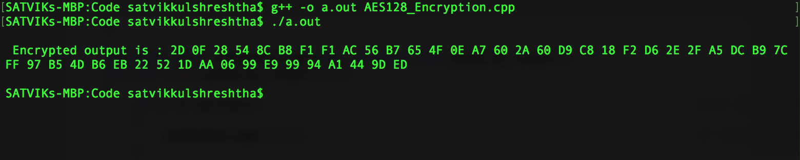

Confirmed Output:

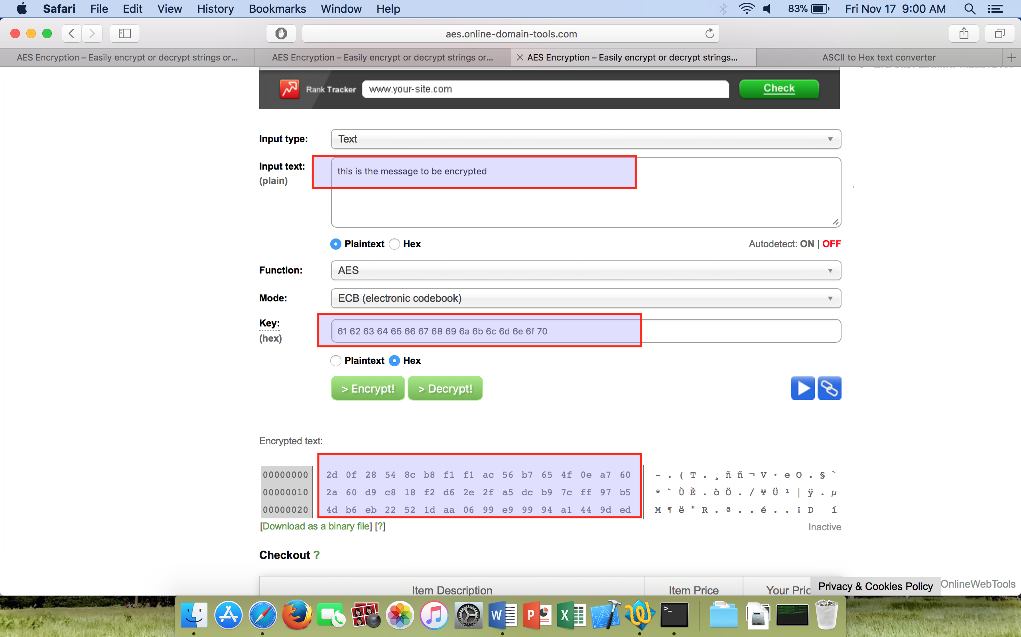

* 1. Test Case 2: (Screenshots attached)

Input text (Plain Text): CSE 178 lab

Key (Plain Text):1 2 3 4 5 6 7 8 9 10 11 12 13 14 15 16

My Output:

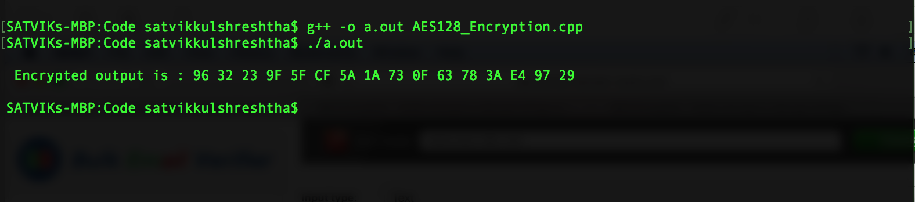

Confirmed Output:

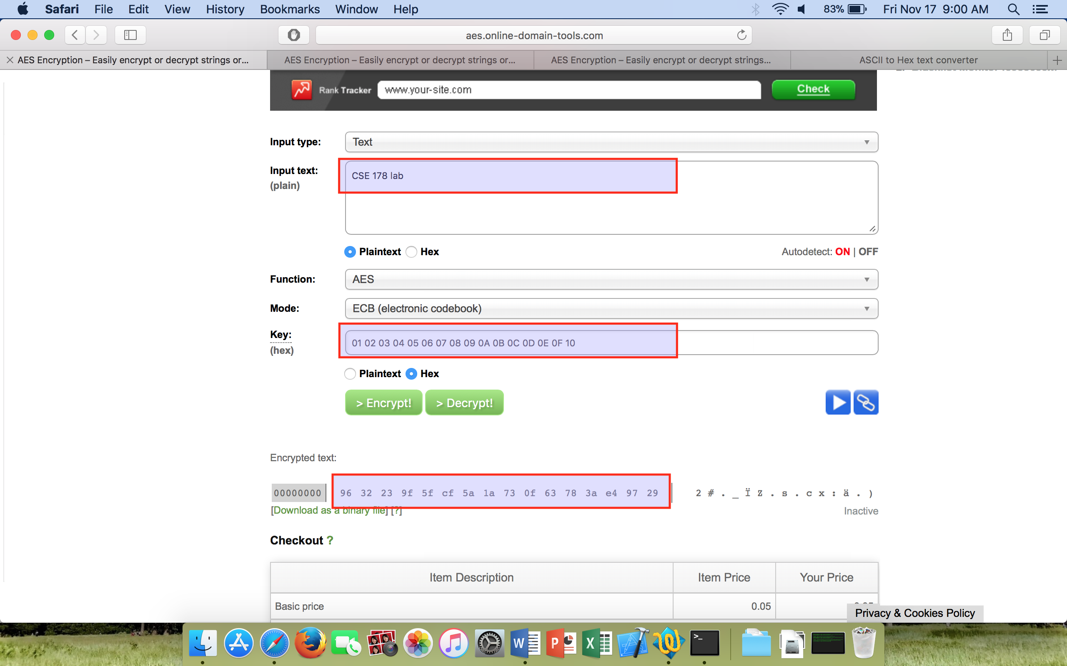

* 1. Test Case 3: (Screenshots attached)

Input text (Plain Text): thats my kung fu

Key (Plain Text): i n p u t k e y f r o m u s e r

My Output:

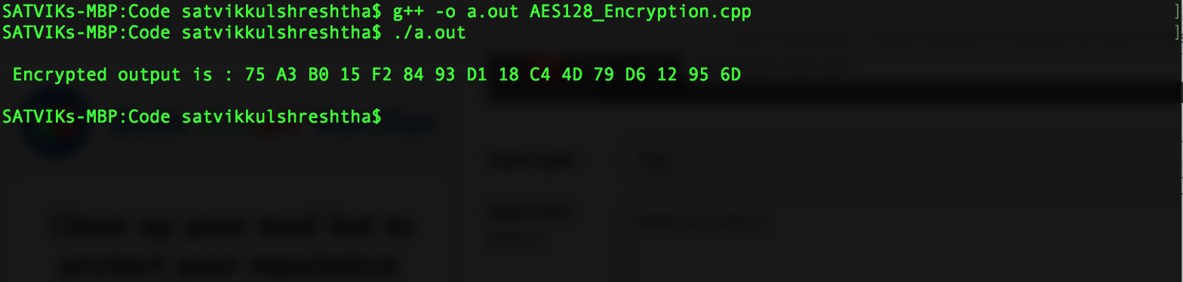

Confirmed Output:

